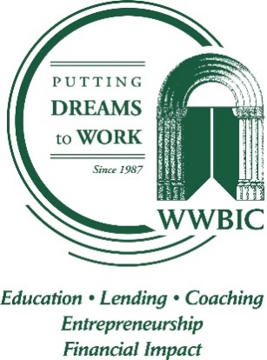 | Position Available: VICE PRESIDENT,  PROGRAMS & OPERATIONS

ABOUT WWBIC
The Wisconsin Women’s Business Initiative Corporation (WWBIC) is a leading innovative statewide economic development corporation that’s been “Putting Dreams to Work” since 1987. We open the doors of opportunity by providing targeted individuals who are interested in starting, strengthening or expanding businesses with access to critical resources such as responsible financial products and quality business and financial education. Our focus is on individuals who face barriers in accessing traditional financing or resources – in particular women, people of color, veterans and low-income individuals.

Every day we work hard to achieve our social goal of improving the economic well-being of individuals by advancing inclusive entrepreneurship and facilitating self-sufficiency strategies. Our statewide team of 50+ works with more than 5,000 clients annually by delivering 26,000 hours of training, counseling and lending services. As Wisconsin’s largest microlender, WWBIC manages a loan portfolio of $20million with 520 active borrowers.

THE OPPORTUNITY
Do you want to help make a difference in Wisconsin communities? WWBIC is currently adding a new senior leadership position to our dynamic team. The VP of Programs & Operations is a full-time position, based out of our Milwaukee headquarters, responsible for directing and expanding WWBIC’s programs and services with a focus on internal operations and process improvement.

KEY RESPONSIBILITIES
- Actively participate on WWBIC’s senior management team to provide leadership to the organization while working collaboratively to set and support agency direction, consistent policies and procedures, and strategic plan implementation.

- Lead WWBIC’s programs and services team to meet or exceed all WWBIC and funder goals; includes business assistance, business lending, education, financial capability, and veterans programs. Measure/improve effectiveness of programs and identify improvement opportunities.

- Lead WWBIC’s Advancement team to improve information collection, flow and communication to internal and external customers. Oversee efforts for development, marketing, grants administration/compliance, funder contracts, and client information management.
- Oversee the human resources functions for the agency. Work collaboratively to promote employee engagement and develop strategies that set WWBIC staff up for success and allow them to deliver consistent, creative, and quality programs and services both internally/externally.

- Supervise and coach staff (paid, consultant, volunteer) with positive influence to achieve results that are in the best interest of the organization. Set priorities, goals and direction; provide support, guidance, encouragement and professional development to team members.

- Manage ongoing, day to day operations and systems across teams, ensuring consistency, efficiency, exemplary customer service and best practices to achieve strategic goals.

- Set goals and direction for team work flow, analysis, metrics, timelines, continuous improvement activities. Orchestrate and support cross-functional team building and problem solving.

THE IDEAL CANDIDATE
- Minimum 10 years experience in economic development, community lending or private sector business leadership role. Solid nonprofit management experience preferred

- Bachelor’s degree required; Advanced degree preferred

- Track record with cross-team operations, supervision of managerial staff, stakeholder relations and financial accountability required.

- Strong organizational, presentation, management, and communication skills; a holistic, systematic approach to organizational issues of a fast-paced and growing organization.

- Working knowledge of community development, small business needs and social entrepreneurship is preferred

- Flexible, enthusiastic, positive, team focused, with a passion for WWBIC’s mission

COMPENSATION
WWBIC will offer you more than just a job We offer the ability to put dreams to work and make a positive difference in the communities where we live and work. In addition to an industry-competitive salary, we have a strong benefit package including Medical, Dental, Life, STD, LTD, 403(b) with match, paid time off and more in a professional and friendly work environment.

TO APPLY
Apply today and explore what’s possible with a career at WWBIC. Send your resume, cover letter, and salary expectations to patricia.lohmann@wwbic.com.

For more information about WWBIC, visit www.wwbic.com

