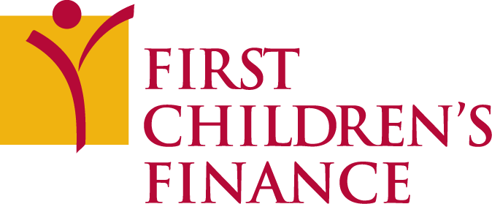

POSITION DESCRIPTION
Director of National Lending

The Opportunity

First Children’s Finance (FCF) is a growing community development financial institution (CDFI) with a mission to grow the supply and business sustainability of excellent child care in the US. Founded in 1991, FCF provides training and financial assistance to entrepreneurs, owners, and leaders in the field of Early Care and Education (ECE). Headquartered in Minneapolis, FCF provides business development programs and/or financing to ECE providers in 20 states, with regional offices in three: Minnesota, Iowa and Michigan. For more information, see the First Children’s website at: http://www.firstchildrensfinance.org. This is a great opportunity to have a real impact on both an organization and a critical sector for our economy and communities throughout the country.

The Position

The Director of National Lending’s role is a strategic one – he/she/they will dramatically grow First Children’s Finance’s lending team and loan fund portfolio, building on the organization’s historical success in creating access to capital for child care entrepreneurs. Reporting to the CEO, the Director will provide leadership to the design and implementation of new and additional financial products and services designed specifically for small child care businesses. With the support of Loan Fund and Portfolio Managers who manage the day to day lending program, the Director will develop strategies that support underserved borrowers and provide equitable access to capital. The Director will also partner with state governments to encourage investments in systemic strategies to extend flexible capital to child care businesses. The Director will align creative lending and access to capital programs with First Children’s Finance’s business development programs, specifically targeting under-served and under-banked communities. FCF’s business development and technical assistance staff which comprise the bulk of the CDFI’s 22 person staff, serve as a source for leads of potential borrowers, and the Loan Fund Manager is responsible for loan application intake and underwriting. The Director will innovate, manage, and promote child care lending and access to capital across the country, and is responsible for supervision of day to day Loan Fund operations.

The Director accomplishes her/his/their purpose through the following responsibilities:
- Promote FCF’s national presence as a child care lending expert
- Create, market, and implement new initiatives that impact underbanked communities
- Innovate new products and capture markets to grow loan fund operations and portfolio
- Lead capital and operational resource development activities for the loan program and partner with other FCF staff on larger fundraising asks
- Develop and maintain effective relationships with government agencies, banks, economic development organizations, CDFI’s and other external partners to continuously support and invest in FCF
- Work with other FCF staff on local, state and national policies and systems that increase loan fund activity
- Work internally with FCF supervisors and related staff to coordinate loan fund responsibilities to ensure consistent client experiences, technical assistance, and program standards
- Ensure compliance with policies and underwriting practices
- Evaluate and share impact of FCF loans on individuals and community child care supply
- Serve as key member of FCF Leadership Team
- Supervise loan program staff

Experience
Required Experience:
- Proven track record of the development and implementation of key fundraising strategies, including experience with cultivating relationships with private, corporate, and public funders, government, and individual donors to secure capital and operational funding
- Demonstrated ability to plan and manage new program development
- Minimum of 5 years executive management, preferably in a nonprofit or CDFI organization
- Demonstrated ability to work effectively with diverse populations in a variety of settings

Preferred Experience:
- Experience in the CDFI industry including relevant experience in underwriting and financial analysis, funding of low-income, and community development activities
- Experience with real estate development and/or community economic development
- Experience in the early care and education industry
- Experience starting or managing programs across multiple states
- Experience with SBA Community Advantage and Microloan programs

Skills
Ability to:
- Represent First Children’s Finance positively at all times, and position First Children’s Finance as a transformative thought leader in the CDFI market space
- Work collaboratively with clients, systems partners, staff, and stakeholders
- Communicate effectively
- Read, interpret, and analyze financial information and develop and manage budgets
- Work with minimal supervision while also being a collaborative and active participant on a larger a team

Personal Attributes
This position requires a leader who is:
- A strategic thinker, detailed planner, and an effective implementer
- Creative, innovative, flexible, and entrepreneurial
- Energetic, enthusiastic and embraces a positive attitude
- Self-motivated
- Collaborative
- Skilled in building innovative products and institutional infrastructure
- A systems thinker who is able to maintain a big-picture focus while attending to detail
- Organized, a self-starter, and a multi-tasker

Education
A bachelor’s degree (or higher) in business, organization development, planning, communications, finance, or a related field is required

Reports To: CEO, Gerald Cutts Status: Full-time; Exempt

Salary and Benefits: Salary is $125,000 with benefits that include medical, dental, life, and disability insurance; holidays, paid time off; and professional development.

To Apply:
Email your application materials (to include resume and cover letter) to our search consultant, David Erickson-Pearson: epdavid@earthlink.net. Application deadline: Open until filled.

